Name: Nicholas M. Schmitz  
Date: You don’t want to know…..

Quick introduction on tools

Windows:

1. Take a screenshot of the Windows Task Manager

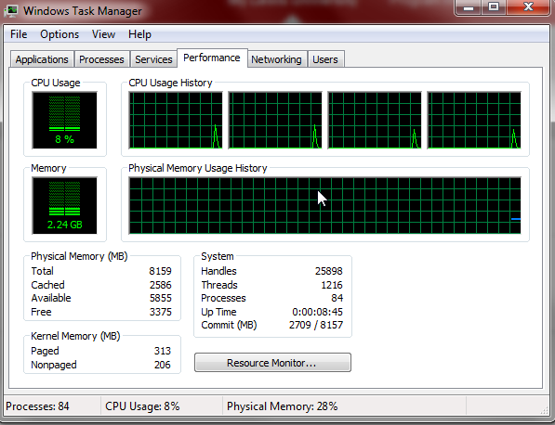

1. Download class sample files from <https://github.com/nadams810/os-70-350/archive/master.zip>

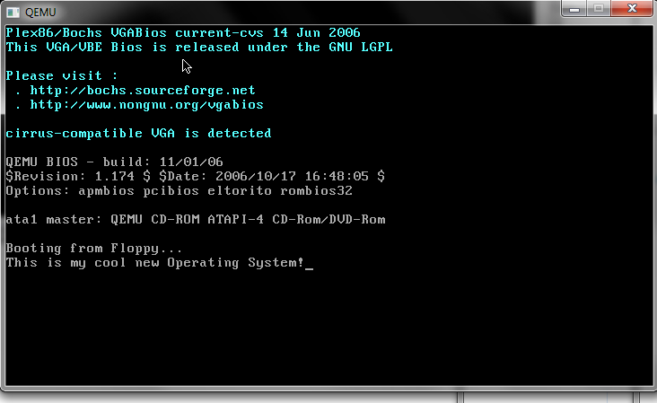

Linux:

(Create a Linux VM – my favorite distro is Debian, Ubuntu is good too or use putty/your favorite SSH client and connect to cs.lewsiu.edu)

1. From a terminal/SSH client
   1. cd
   2. mkdir os-class
   3. cd os-class
   4. wget -O sample.c <http://goo.gl/mhrwr9>
   5. gcc -g sample.c
   6. ./a.out
   7. Does it crash? _YES
2. Let’s figure out why
   1. gdb ./a.out
   2. r (for run)
   3. print z
   4. What’s the value of z? (int*) 0x0 = null
   5. print i
   6. What’s the value of i? 0
   7. Exit by hitting ctrl+d or type quit
      1. If it asks if you really want to quit – type y
   8. Fix z by either making it a stack variable or allocating/freeing the memory from the heap
   9. Paste the fixed code below (you can copy/paste out of a terminal window, in putty selecting puts the text into your clipboard automatically):

#include <stdio.h>

int main()

{

int x[10];

int i;

int z = NULL;

for(i = 0; i < 10; i++)

printf("%i", i + z);

return 0;

1. }